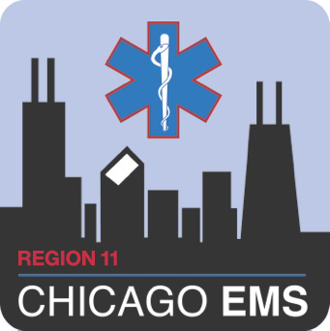
ADVOCATE ILLINOIS MASONIC MEDICAL CENTER
JOHN H. STROGER JR. HOSPITAL OF COOK COUNTY
NOR THWESTERN MEMORIAL HOSPITAL
UNIVERSITY OF CHICAGO MEDICAL CENTER

EMS Provider Data Form
PERSONAL INFORMATION SECTION A
Last Name: First Name: MI:
Home Address: Apartment:
City: State Zip Code: County:
Home Phone: ( ) - Cell Phone: ( ) -
DOB: Social Security #: - -
**E-mail Address**:
EMPLOYER INFORMATION SECTION B
Current Primary Employer:
Employer File Number:
Have you ever worked in the Region 11 Chicago EMS System before () Yes () No

If so, who did you work for? When? / /
EDUCATION INFORMATION SECTION C
Level of Training: () First Responder () EMT () Paramedic () ECRN () Emergency Medical Dispatcher
() MD
EMT/Paramedic Training Program: Date Graduated:

Address:

City: State: Zip Code:

LICENSE INFORMATION SECTION D
IDPH License Number: / / / / / / / / / /

Expiration Date: / /

CPR Expiration Date: / /

CERTIFICATIONS SECTION E
Please attach legible copies of all current cards (both sides):
() ACLS Provider () ACLS Instructor () ITLS Provider () ITLS Instructor () Critical Care Paramedic
() PEPP Provider () PEPP Instructor () CPR Instructor () IDPH Licensed EMS Lead Instructor
() PALS Provider () PALS Instructor () PHTLS Basic Provider () PHTLS Advanced Provider
() PHTLS Instructor

PERSONAL BACKGROUND INFORMATION SECTION F
Have you ever had any disciplinary action taken against you, or have you ever been suspended in ANY EMS System that you have worked in previously? ( ) Yes () No
Have you ever had your license suspended, removed, or revoked? () Yes () No
Have you ever been convicted of a felony? () Yes () No
If you answered YES to any of the above questions, please explain below, giving dates, details and dispositions:

EMS SYSTEM ENTRY APPLICANT STATEMENT SECTION G
I understand that I will not be permitted to take the Region 11 Chicago EMS System Entry Examination until the following items have been received: IDPH EMT or Paramedic license, current CPR certification, current Drivers License; completed EMS Provider Data Form, and a letter of good standing from any current EMS Systems. Furthermore, I must pass the Region 11 Chicago EMS System Entry cognitive (written) examination with a minimum score of 75% and pass the psychomotor (practical) examination (per “System Entry Policy” in the Region 11 Policy Manual).

I have received a copy of the current Chicago EMS System Protocols, Policies, and Procedures and agree to abide by these guidelines while functioning as an EMT, Paramedic, ECRN or Emergency Medical Dispatcher in the Region 11 Chicago EMS System.

I also understand that I must notify my Resource Hospital of any name, address, employer or licensing changes within three days, as stated in the Region 11 EMS Policy Manual.

I understand that I will be responsible for meeting all CE requirements per IDPH Emergency Medical Services Act and Region 11 Chicago EMS System Policy. Furthermore, I will maintain documentation of CE done outside of Region 11 and submit mandatory continuing education immediately upon completion.

I understand that falsification, misrepresentation, or omission of information on this application is grounds for denial into or removal from the Chicago EMS System as defined in the Illinois Department of Public Health (IDPH) EMS Act.

Applicant’s Signature: Date:

