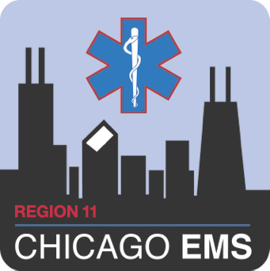
ADVOCATE ILLINOIS MASONIC MEDICAL CENTER
JOHN H. STROGER JR. HOSPITAL OF COOK COUNTY
NOR THWESTERN MEMORIAL HOSPITAL
UNIVERSITY OF CHICAGO MEDICAL CENTER

Region 11 EMS Lead Instructor Application

Initial Application for an EMS Lead Instructor (LI) License in the Region 11 Chicago EMS System requires minimum education and experience requirements. Renewal Applications for an EMS LI License require documented continuing education hours including delivery, development, and evaluation of education programs. Applicants should fill out this form for the Initial EMS Lead Instructor License, as required by IDPH, and return it to the applicant’s Resource Hospital with supporting documentation as detailed in the EMS System Policy “EMS Lead Instructor”.

Complete applications will be submitted by the Resource Hospital to IDPH. Upon receipt of the new license, applicants should upload a copy of the license in Target Solutions and update the license information on their profile.
Personal Information: |  |  |  |  |  |  |  |  |  |  |  |  |  |  |  |  |  |  |  |  |  |  |  |  |  |  | Section A
Last Name: |  |  |  |  |  |  | First: |  |  |  |  |  |  |  |  |  |  |  |  |  | DOB:
Home Address:
City: |  |  |  |  |  |  | State: |  |  |  |  |  | Zip: |  |  |  |  |  |  |  |  |  |  |  |  |  |  | SSN:
Cell Phone: |  |  |  |  |  |  | Email:
Professional Information: |  |  |  |  |  |  |  |  |  |  |  |  |  |  |  |  |  |  |  |  |  |  |  |  |  |  | Section B
Employer: |  |  |  |  |  |  | Current Rank/Position:
Years in EMS: |  |  |  | Resource Hospital:
Other related professional information:
Current Licenses: |  |  |  |  |  |  |  |  |  |  |  |  |  |  |  |  |  |  |  |  |  |  |  |  |  | Section C
IDPH License #: |  |  |  |  |  |  |  |  | Lead Instructor Course Date:
Initial Date: | Expiration Date: |  |  |  |  |  |  |  | LI License Expiration (Renewal):
Describe your experience in prehospital emergency care: |  |  |  |  |  |  |  |  |  |  |  |  |  |  |  |  |  |  |  |  |  |  |  |  |  | Section D
List Teaching Experience (Date, Course/Topic, Role, Location): |  |  |  |  |  |  |  |  |  |  |  |  |  |  |  |  |  |  |  |  |  |  |  |  |  | Section E
Describe your experience in pre-hospital emergency care:
Educational References: |  |  |  |  |  |  |  |  |  |  |  |  |  |  |  |  |  |  |  |  |  |  |  |  |  |  | Section F
Name |  |  |  | Position |  |  |  |  |  |  |  |  |  |  | Phone Number
Acknowledgement |  |  |  |  |  |  |  |  |  |  |  |  |  |  |  |  |  |  |  |  |  |  |  |  |  |  | Section G
I verify all the above information is true and my references may be contacted to support my teaching experience.
Signature: |  |  |  |  |  |  |  |  |  |  |  |  |  |  | Date:

