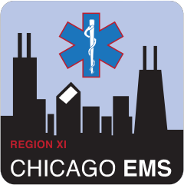
ADVOCATE ILLINOIS MASONIC MEDICAL CENTER
JOHN H. STROGER JR. HOSPITAL OF COOK COUNTY NOR THWESTERN MEMORIAL HOSPITAL
UNIVERSITY OF CHICAGO MEDICAL CENTER

January 2019
Region XI EMS Monthly Pearls

- All EMTs, Paramedics, ECRNs, and ECPs should complete the mandatory Cardiac Updates 2018 education prior to January 11th, 2019

- Cardiac Arrest resuscitations require field to hospital contact with Online Medical Control, these should not be pre-notification reports. Patients with ROSC or ongoing resuscitation should be transported to a STEMI Center.

- Stroke Assessment consists of a Cincinnati Stroke Scale, Finger to Nose, 3 Item Stroke Scale and last known normal to determine transport to a Primary Stroke Center or Comprehensive Stroke Center.

- The 3 Item Stroke Scale (3I-SS) is scored based on Level of Consciousness, Gaze Preference, and Motor Function.

- ETCO2 waveform capnography is mandatory for all advanced airways and values should be documented in the patient care report.

Questions? Contact your hospital EMS Coordinator or EMS Medical Director

